**Bugs Summary:**

BUG REPORT DOCUMENT

|  |  |
| --- | --- |
| Registration Page Bugs | 3 |
| Contact Page Bugs | 9 |
| Office Search Functionality Bugs | 1 |
| Broken Link Bugs | 1 |
| Complaint Page Bugs | 12 |
| Total Bugs | 26 |

# Bug ID: 001

**Title:** Facebook icon does not redirect to the correct Facebook page on the homepage.

**Description:** When a user clicks on the Facebook icon on any page, they are not redirected to the correct Facebook page. This issue prevents users from accessing NADRA official Facebook page.

## Steps to Reproduce:

1. Load the homepage.
2. Click on the Facebook icon.

**Expected Result:** The user should be redirected to the correct NADRA Facebook page.

**Actual Result:** The user is not redirected to the correct NADRA Facebook page. Severity: Medium

Priority: Medium

## Environment:

**Browser**: Google Chrome, Firefox, Edge **Operating System**: Window, Android **Device:** Desktop, Mobile,

**Network:** Wi-Fi, 4G

## Attachments:

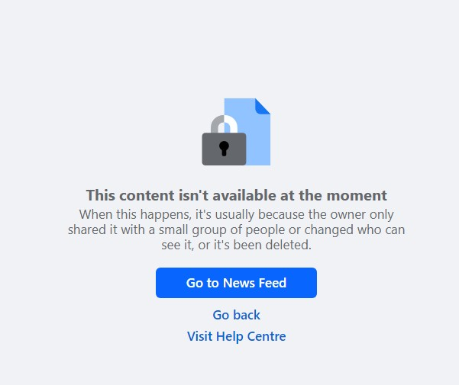

**Suggestion:**

Ensure that the Facebook icon's link is correctly configured to direct users to the correct Facebook page.

# Bug ID: 002

**Title:** Search functionality does not perform for multiple times (search after search)

**Description:** The search functionality on the Offices page fails to execute multiple searches at a time. When different search criteria are selected and the search button is clicked, the search results are not updated as expected.

## Steps to Reproduce:

1. Select "Karachi" from the Regional Office dropdown.
2. Select "Hyderabad" from the District dropdown.
3. Select "Morning" from the Shift Time dropdown.
4. Click the search button.
5. Observe the search results.
6. Repeat steps 1 to 4 with different test data for 3 times: "Lahore", "District Faisalabad", "Morning"

Another set of data Another set of data

## Expected Result:

The search functionality should update the search results according to the new criteria each time the search button is clicked.

## Actual Result:

The search functionality does not update the search results after the first search, failing to perform multiple searches.

**Severity**: Medium **Priority:** High **Environment:**

**Browser**: Google Chrome, Firefox, Edge **Operating System**: Window, Android **Device:** Desktop, Mobile,

**Network:** Wi-Fi, 4G

## Attachments:

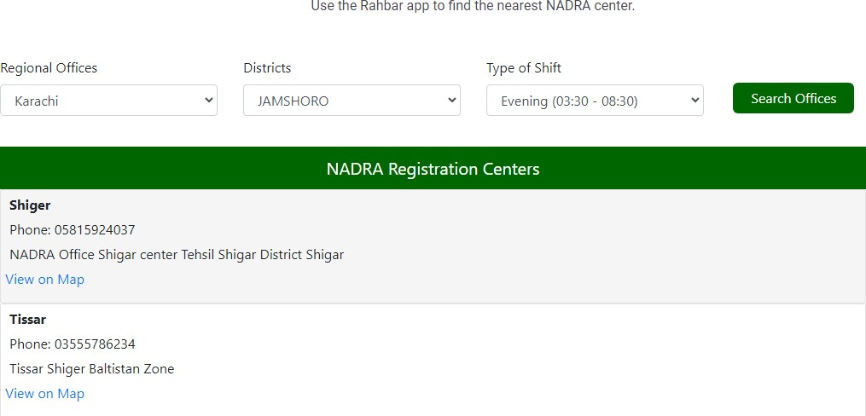

**Suggestion:** This bug impacts the usability of the search functionality, requiring users to refresh the page or take additional steps to perform multiple searches. It is critical to address this issue to ensure a smooth user experience.

# Bug ID: 003

**Title**: Absence of Eye Button in Password Field on Registration Page

**Description:** The registration page does not display the eye button next to the password field, which is expected to be present for users to toggle the visibility of their password.

## Steps to Reproduce:

1. Navigate to the registration page.
2. Locate the password field.
3. Check for the presence of the eye button next to the password field.

**Expected Result:** The eye button should be present next to the password field, allowing users to toggle the visibility of their password.

**Actual Result:** There is no eye button present next to the password field.

**Severity**: Medium **Priority**: High **Environment:**

**Browser**: Google Chrome, Firefox, Edge **Operating System**: Window, Android **Device:** Desktop, Mobile,

**Network:** Wi-Fi, 4G

## Attachments:

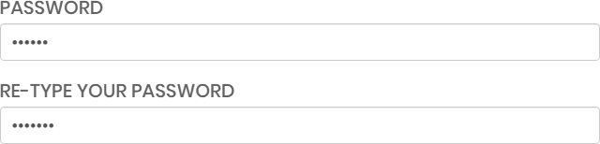

**Suggestion:**

This issue affects the user experience as it prevents users from easily verifying their password input.

# Bug ID: 004

**Title**: Country Dropdown List Missing Certain Country Names

**Description**: The country dropdown list on the registration page is missing several country names, including Afghanistan, Armenia, and Bhutan.

## Steps to Reproduce:

1. Navigate to the registration page.
2. Click on the country dropdown list.
3. Review the list of country names.

**Expected Result:** The dropdown list should contain all country names.

**Actual Result:** The dropdown list is missing several country names, such as Afghanistan, Armenia, and Bhutan.

**Severity**: Medium **Priority**: High **Environment:**

**Browser**: Google Chrome, Firefox, Edge **Operating System**: Window, Android **Device:** Desktop, Mobile,

**Network:** Wi-Fi, 4G

## Attachments:

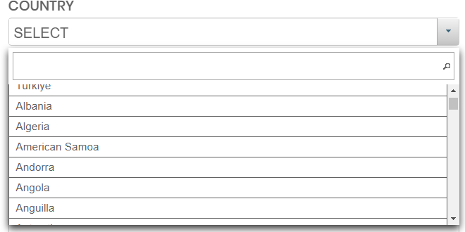

**Suggestion:**

Ensure that the list includes all recognized country names.

# Bug ID: 005

**Title**: Name Field Not Validated as Mandatory in Contact Us Form

**Description**: The Contact Us form does not display an error message when the Name field is left empty and the form is submitted. The form submission fails silently without informing the user that the Name field is required.

## Steps to Reproduce:

1. Navigate to the Contact Us page.
2. Leave the Name field empty.
3. Fill in the Email field with "[Haseeb@gmail.com](mailto:Haseeb@gmail.com)".
4. Fill in the Subject field with "complaint".
5. Fill in the Message field with "hello".
6. Click the "Submit" button.

**Expected Result:** An error message should be displayed indicating that the Name field is required. **Actual Result:** Nothing happens when the "Submit" button is clicked. No error message is displayed. **Severity**: Major

**Priority**: High

## Environment:

**Browser**: Google Chrome, Firefox, Edge

**Operating System**: Window, Android

**Device:** Desktop, Mobile,

**Network:** Wi-Fi, 4G

## Attachments:

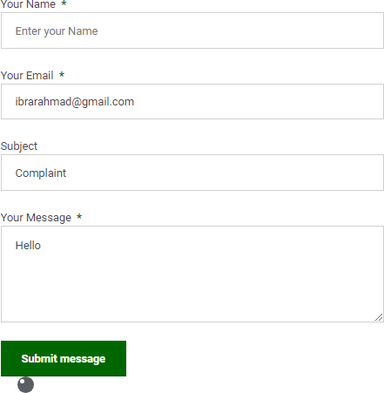

**Suggestions:**

Ensure the Name field is marked as mandatory in the form validation logic.

# Bug ID: 006

**Title**: Missing Error Message for Mandatory Email Field on Contact Us Page

**Description:** The Contact Us form does not display an error message when the Email field is left empty, which prevents users from understanding why their submission is not being accepted.

## Steps to Reproduce:

1. Navigate to the Contact Us page.
2. Leave the Email field empty.
3. Fill in the Name, Subject, and Message fields with the following data: Name: Haseeb Akram

Subject: Complaint Message: Hello

1. Click the "Submit" button.

**Expected Result:** An error message should be displayed indicating that the Email field is required. **Actual Result:** Nothing happens when the "Submit" button is clicked. No error message is displayed. **Severity**: High

**Priority**: Medium

## Environment:

**Browser**: Google Chrome, Firefox, Edge

**Operating System**: Android

**Device:** Mobile **Network:** Wi-Fi, 4G **Attachments:**

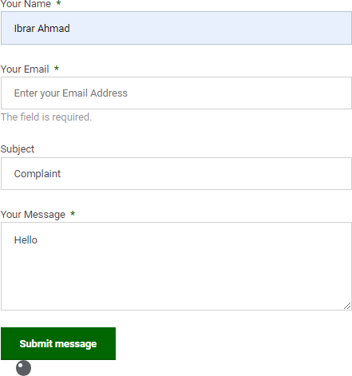

## Suggestions:

Ensure the error message is displayed and clearly indicates that the Email field is required.

# Bug ID: 007

**Title**: Missing Error Message for Mandatory Message Field on Contact Us Page

**Description**: When submitting the Contact us form, the validation for the Message field being mandatory is not functioning correctly. Submitting the form without filling in the Message field does not display an error message, and the form does not get submitted.

## Steps to Reproduce:

1. Navigate to the Contact Us page.
2. Leave the Message field empty.
3. Fill in the Name and Subject fields with valid data.
4. Click on the "Submit" button.

**Expected Result**: An error message should be displayed indicating that the Message field is required. **Actual Result**: Nothing happens when the "Submit" button is clicked. No error message is displayed. **Severity**: High

**Priority**: Critical

## Environment:

**Browser**: Google Chrome, Firefox, Edge **Operating System**: Window, Android **Device:** Desktop, Mobile,

**Network:** Wi-Fi, 4G

## Attachments:

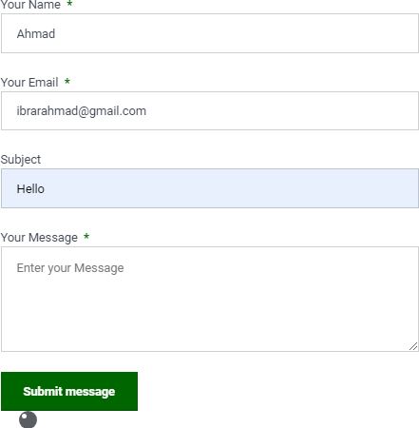

**Suggestions:**

Consider adding inline error messages for better user experience.

# Bug ID: 008

**Title**: Contact Form Submission Allows Invalid Email Format

**Description**: When submitting the contact form with an invalid email format, no error message is displayed, and the form submission does not proceed. The email field should validate the email format and display an appropriate error message if the format is invalid.

## Steps to Reproduce:

1. Navigate to the Contact Us page.
2. Enter an invalid email format in the Email field (e.g., `Ibragmail.com`).
3. Fill in the Name, Subject, and Message fields with valid data. Name: Haseeb Akram

Subject: complaint Message: Hello

1. Click the "Submit" button.

**Expected Result**: An error message should be displayed indicating that the email format is invalid. **Actual Result**: Nothing happens when the "Submit" button is clicked. No error message is displayed. **Severity**: Medium

**Priority**: High

## Environment:

**Browser**: Google Chrome, Firefox, Edge **Operating System**: Window, Android **Device:** Desktop, Mobile,

**Network:** Wi-Fi, 4G

## Attachments:

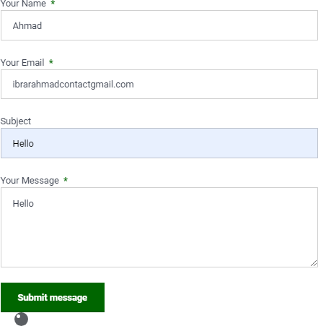

**Suggestion:**

Ensure that an appropriate error message is displayed if the email format is invalid.

# Bug ID: 009

Title: Contact Form Submission Failure on Desktop

Description: The contact form on the Contact Us page does not submit when valid data is entered and the "Submit" button is clicked. No error message is displayed to indicate the cause of the failure.

Steps to Reproduce:

1. Navigate to the NADRA Identity Services web app.
2. Go to the Contact Us page on a desktop device.
3. Enter the following data in the respective fields: Name: Haseeb Akram

Email: Haseebakram97@gmil.com

Subject: Complaint Message: Hello

1. Click the "Submit" button.

**Expected Result**: The form should be submitted successfully, and a success message should be displayed.

**Actual Result**: Nothing happens when the "Submit" button is clicked. No error message is displayed.

**Severity**: Medium **Priority**: Immediate **Environment:**

**Browser**: Google Chrome, Firefox, Edge

**Operating System**: Window

**Device:** Desktop

**Network:** Wi-Fi

## Attachments:

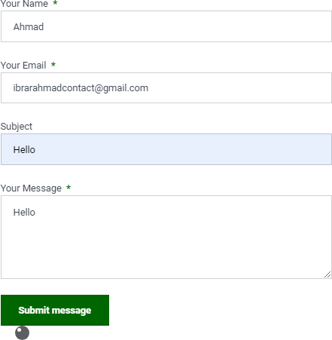

**Suggestions:**

Add error handling to display appropriate messages to the user if the form submission fails.

# Bug ID: 010

**Title**: Contact Form Submission Failure on Mobile Device

**Description**: The contact form submission process fails on mobile devices. When valid data is entered in the form fields and the "Submit" button is clicked, nothing happens. No error message is displayed, and the form is not submitted.

## Steps to Reproduce:

1. Navigate to the Contact Us page on a mobile device.
2. Enter valid data in the following fields: Name: Haseeb Akram

Email: [Haseebakram97@gmail.com](mailto:Ibrar@gmail.com) Subject: Complaint Message: Hello

1. Click the "Submit" button.

**Expected Result:** The form should be submitted successfully, and a success message should be displayed.

**Actual Result**: Nothing happens when the "Submit" button is clicked. No error message is displayed.

**Severity**: High **Priority**: High **Environment:**

**Browser**: Google Chrome **Operating System**: Android **Device:** Mobile,

**Network:** Wi-Fi, 4G

## Attachments:

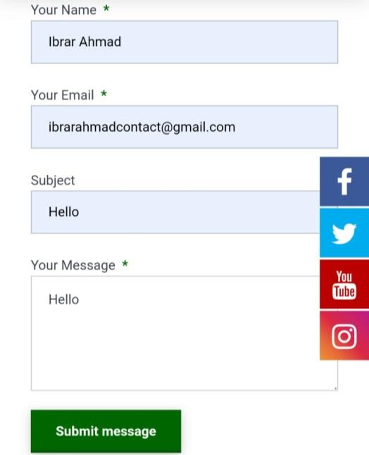

**Suggestions:**

Ensure that form validation and submission processes are correctly handled across all devices and browsers.

# Bug ID: 011

**Title**: Contact Form Submission Failure on Chrome Browser

**Description**: The contact form on the "Contact Us" page fails to submit when valid data is entered, and the "Submit" button is clicked. No success or error message is displayed.

## Steps to Reproduce:

1. Open the Chrome browser.
2. Navigate to the "Contact Us" page of the NADRA Identity Services web app.
3. Enter the following valid data in the form fields: Name: Haseeb Akram

Email: [Haseebakram97@gmail.com](mailto:Ibrar@gmail.com) Subject: Complaint Message: Hello

1. Click the "Submit" button.

**Expected Result:** The form should be submitted successfully, and a success message should be displayed.

**Actual Result:** Nothing happens when the "Submit" button is clicked. No error message is displayed.

**Severity**: High **Priority**: Immediate **Environment:**

**Browser**: Google Chrome, Firefox, Edge **Operating System**: Window, Android **Device:** Desktop, Mobile,

**Network:** Wi-Fi, 4G

## Attachments:



**Suggestions:**

Ensure that the form fields are correctly validated and that appropriate messages are displayed upon form submission.

# Bug ID: 012

**Title**: Contact Form Submission Fails on Firefox Browser

**Description:** The contact form on the "Contact Us" page does not submit when using the Firefox browser. The form does not display any error message or indication that submission has failed.

## Steps to Reproduce:

1. Navigate to the "Contact Us" page using Firefox browser.
2. Enter valid data in the following fields:

Name: Haseeb Akram Email: [Haseebakram97@gmail.com](mailto:Ibrar@gmail.com) Subject: Complaint Message: Hello

1. Click the "Submit" button.

**Expected Result:** The form should be submitted successfully, and a success message should be displayed.

**Actual Result:** Nothing happens when the "Submit" button is clicked. No error message is displayed.

**Severity**: Major **Priority**: High **Environment:**

**Browser**: Firefox

**Operating System**: Window, Android

**Device:** Desktop, Mobile,

**Network:** Wi-Fi, 4G

## Attachments:



**Suggestions:**

Ensure that form submission functionality is consistent across all supported browsers.

# Bug ID: 013

**Title**: Form Submission Failure on Contact Us Page in Edge Browser

**Description**: When attempting to submit the contact form on the Contact Us page using the Edge browser, the form does not submit, and no error message is displayed. This prevents users from sending their inquiries or feedback.

## Steps to Reproduce:

1. Open the Contact Us page on the Edge browser.
2. Enter the following valid data into the form fields: Name: Haseeb Akram

Email: [Haseebakram97@gmail.com](mailto:Ibrar@gmail.com)

Subject: complaint Message: Hello

1. Click the "Submit" button.

**Expected Result:** The form should be submitted successfully, and a success message should be displayed indicating that the submission was successful.

**Actual Result**: Nothing happens when the "Submit" button is clicked. No success or error message is displayed.

**Severity**: High **Priority**: High **Environment:**

**Browser**: Edge

**Operating System**: Window, Android

**Device:** Desktop, Mobile, **Network:** Wi-Fi, 4G

**Attachments:**



## Suggestions:

Test the form submission on other browsers to determine if the issue is specific to Edge.

# Bug ID: 014

**Title**: Contact Form Submission Fails to Display Error Messages for Empty Fields

**Description:** The Contact Us form does not display error messages when the required fields (Name, Email, Message) are left empty and the form is submitted. This issue prevents users from understanding that these fields are mandatory.

## Steps to Reproduce:

1. Navigate to the Contact Us page.
2. Leave the Name, Email, and Message fields empty.
3. Click the "Submit" button.

**Expected Result:** Error messages should be displayed indicating that the Name, Email, and Message fields are required.

**Actual Result:** Nothing happens when the "Submit" button is clicked. No error message is displayed.

**Severity**: High

**Priority**: Immediate

**Environment**:

**Browser**: Google Chrome, Firefox, Edge **Operating System**: Window, Android **Device:** Desktop, Mobile,

**Network:** Wi-Fi, 4G

**Attachments**:

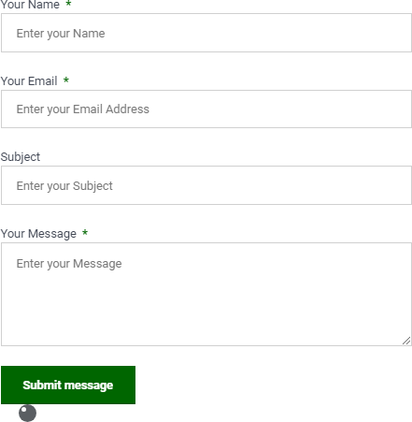

# Bug ID: 015

**Title**: Validate without entering the data in the CONTACT NUMBER form not submitted

**Description**: When enter other data in Complaint page but contact number is not Enter in Contact number field the form should be not submitted without contact number

## Steps to Reproduce:

1. Open the web browser.
2. Navigate to complaints page from home page
3. Enter data name, email, and complaint type and complaint detail and submit the complaint.

**Expected Result**: Without entering the data in the CONTACT NUMBER form should not be submitted the data

**Actual Result:** Without entering the number in the CONTACT NUMBER form is submitted

**Severity**: low

**Priority**: low

**Environment**:

**Browser**: Google Chrome, Firefox, Edge **Operating System**: Window, Android **Device:** Desktop, Mobile,

**Network:** Wi-Fi, 4G

**Attachments**:

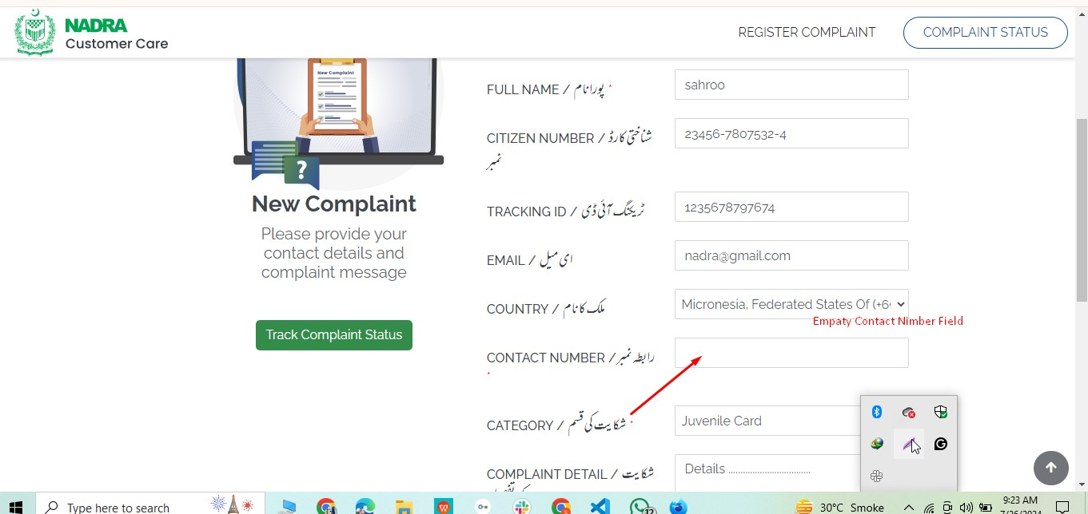

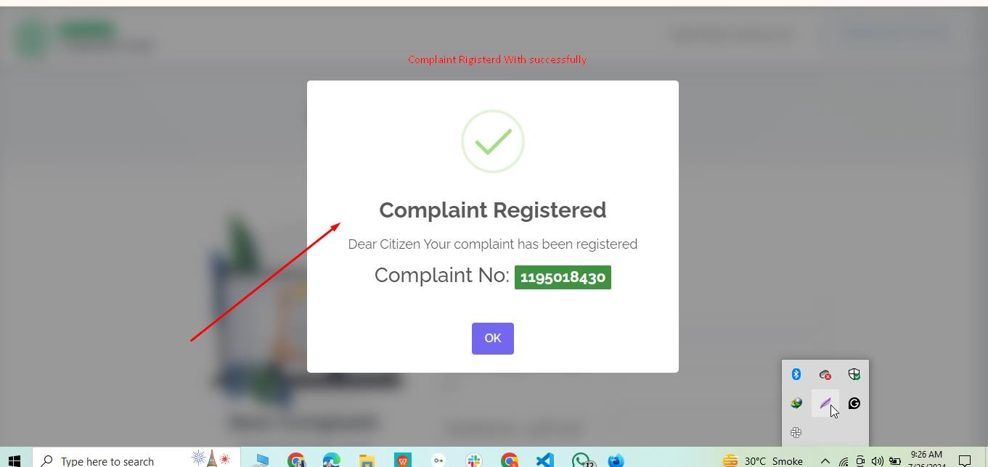

# Bug ID: 016

Title: Verify that Special characters are not enter in name field

Description: Only alphabetic words are Entered in the name field, special characters are not enter in name field

## Steps to Reproduce:

1. Open the web browser.
2. Navigate to the complaints page from the home page

**Expected Result:** Special characters should not be entered in name field

**Actual Result:** Special characters are entered in name field

**Severity**: Medium **Priority**: Medium **Environment**:

**Browser**: Google Chrome, Firefox, Edge **Operating System**: Window, Android **Device:** Desktop, Mobile,

**Network:** Wi-Fi, 4G

**Attachment:**

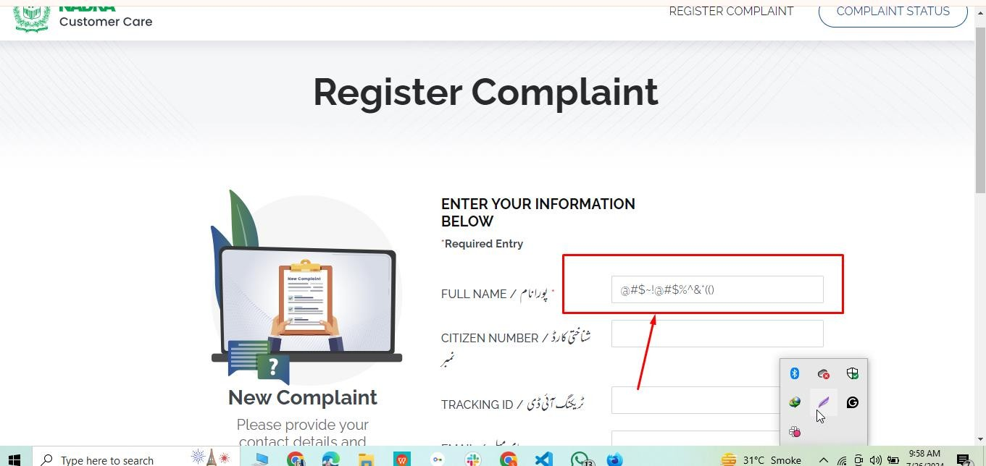

# Bug ID: 017

**Title**: Verify that the numbers can't be enter in name field

**Description**: Only alphabetic words are entered in the name field, NUMBERS are not entered in name field

## Steps to Reproduce:

1. Open the web browser.
2. Navigate to the complaints page from the home page
3. Enter the Numbers in Name field

**Expected Result:** The numbers Should not be entered in name field

**Actual Result:** The numbers are entered in name field

**Severity**: Medium **Priority**: Medium **Environment:**

**Browser**: Google Chrome, Firefox, Edge **Operating System**: Window, Android **Device:** Desktop, Mobile,

**Network:** Wi-Fi, 4G

# Bug ID:017

**Title**: Verify that an invalid citizen ID can't be accepted

Description: Only alphabetic words are Entered in the name field, NUMBERS are not entered in name field

## Steps to Reproduce:

1. Open the web browser.
2. Navigate to the complaints page from the home page
3. Enter the wrong citizen number

**Expected Result:** Invalid citizen ID should not be accepted

**Actual Result:** Invalid citizen Id is accepted

**Severity**: Medium

**Priority**: Medium

**Environment:**

**Browser**: Google Chrome, Firefox, Edge **Operating System**: Window, Android **Device:** Desktop, Mobile,

**Network:** Wi-Fi, 4G

**Attachment**:

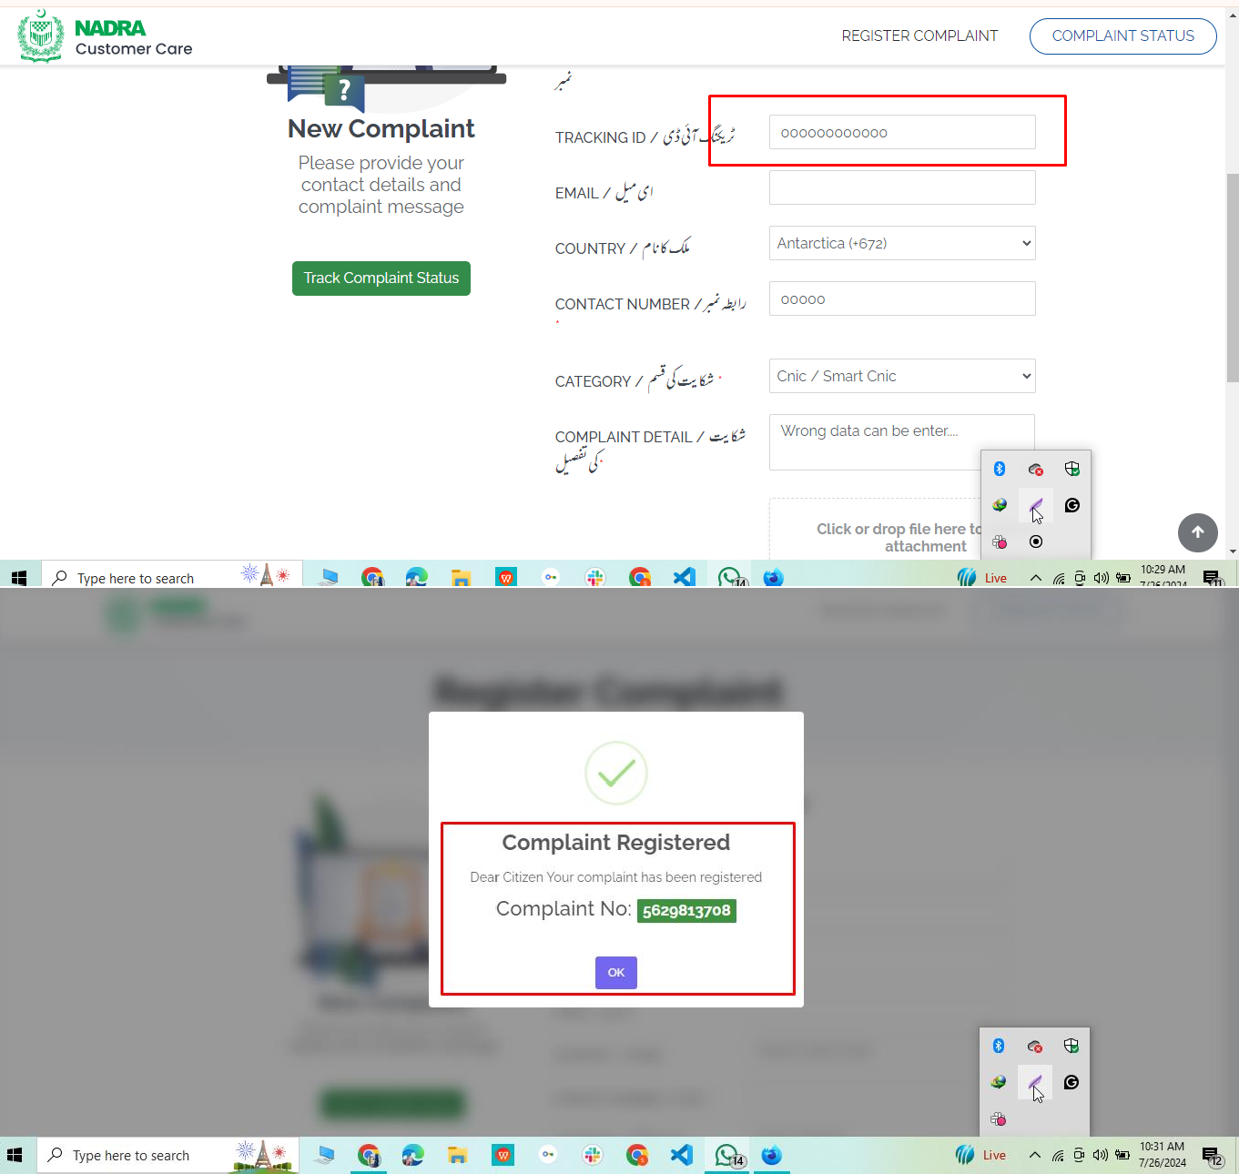

# Bug ID: 018

**Title**: PDF File Upload Fails on Complaint Registration Page

**Description**: The system fails to upload a PDF file on the complaint registration page. Users are unable to submit their complaints due to this issue.

## Steps to Reproduce:

1. Open the web browser.
2. Navigate to the complaints page from the home page.
3. Attempt to upload a PDF file.

**Expected Result**: The PDF file should be uploaded without any error.

**Actual Result**: The PDF file is not uploading.

**Severity**: High **Priority**: Critical **Environment**:

**Browser**: Google Chrome, Firefox, Edge **Operating System**: Window, Android **Device:** Desktop, Mobile,

**Network:** Wi-Fi, 4G

## Attachme